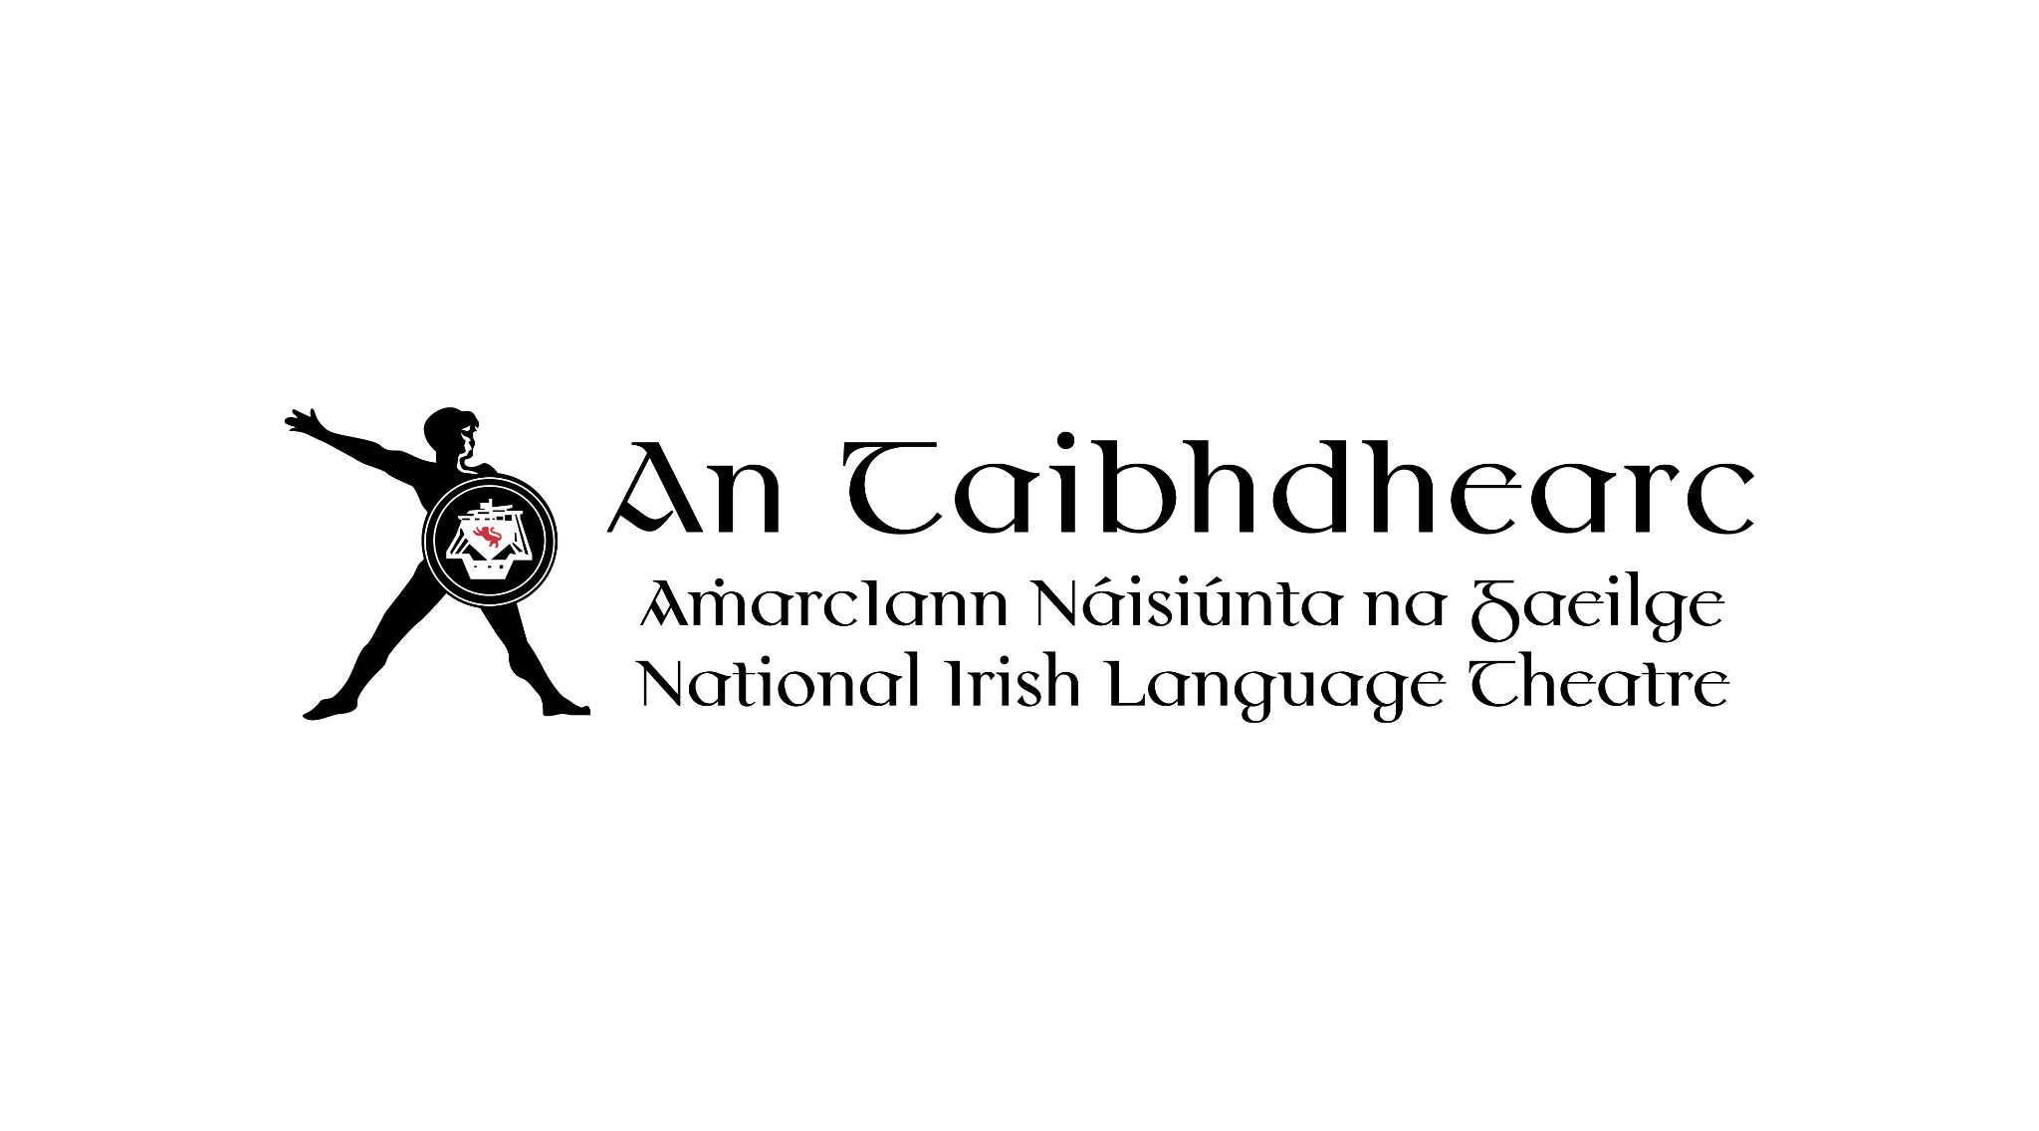
Teideal an Phoist: Comhordaitheoir Rochtana (Páirtaimseartha, Conradh Seasta – Meitheamh 2026 go Aibreán 2028)

Maidir leis an Eagraíocht:
Is í An Taibhdhearc amharclann náisiúnta na Gaeilge. Cruthaímid, cuirimid i láthair, agus
tacaímid leis na taibhealaíona, a chuimsíonn nuálaíocht agus ilghnéitheacht. Déanann muid é
seo le agus ar son ealaíontóirí agus pobail na Gaeilge ar fud na tíre agus ar fud an domhain.

Maidir leis an Ról:
Tá An Taibhdhearc ag lorg Comhordaitheoir Rochtana páirtaimseartha a bheidh mar dhuine lárnach inár bhfoireann, ag obair le comhghleacaithe chun rochtain a fheabhsú i slite éagsúla ins An Taibhdhearc agus i measc ár gcomhphobail, le hearnáil níos ionchuimsithe agus rochtanach a neartú de réir a chéile. Déanfaidh muid ár ndícheall é seo a dhéanamh tríd ár tionscnaíocht “Rochtain”.

Maidir leis an Togra:
Tá easpa sholáthair rochtana ar fáil d’ealaíona i nGaeilge agus i mionteangacha eile. Tá maoiniú faighte ag An Taibhdhearc ó Rethink Ireland don togra “Rochtain” le taighde earnála a dhéanamh agus le hacmhainní breise a chur ar fáil do luchtanna féachana agus rannpháirtithe atá faoi mhíchumais éagsúla, le cur le hearnáil ionchuimsitheach, inrochtana.

Beidh an té a cheapfar freagrach as an obair seo a leanas chomh maith le cúraimí eile:

- Bainistiú a dhéanamh ar an togra “Rochtain”, le tacaíocht ón Stiúrthóir Ealaíne agus ón Léiritheoir.
- Earcaíocht a dhéanamh le painéal comhairleach a aimsiú, cruinnithe rialta a eagrú leo, agus comhairle an phainéil a chur chun cinn más cuí.
- Comhairle a chur ar fhoireann na Taibhdheirce agus ar fhoirne léiriúcháin maidir le hacmhainní inrochtaineacha a d’fhéadfaí a úsáid le linn léirithe agus imeachtaí (Teanga Chomharthaíochta na hÉireann, fortheidil i nGaeilge agus i mBéarla, léirithe suaimhneacha, srl).
- Buiséad an togra a bhainistiú.
- Taighde a dhéanamh ar acmhainní inrochtaineacha a bhíonn in úsáid in earnáil na n-ealaíon agus in earnálacha eile.
- Tuairiscí a ullmhú do Rethink Ireland go ráithiúil.
- Freastal ar chruinnithe agus imeachtaí de chuid An Taibhdhearc agus Rethink Ireland.
- Oiliúint um Chomhionannas do Dhaoine faoi Mhíchumas ó Arts & Disability Ireland a eagrú d’fhoireann na Taibhdheirce agus d’ealaíontóirí a bhíonn ag obair leis An Taibhdhearc.
- Polasaí Chomhionnanais, Éagsúlachta agus Chuimsitheachta a fhorbairt i dteannta leis an bpainéal comhairleach agus daoine ábhartha eile.
- Páirt a ghlacadh i gcruinnithe pleanála ábhartha nuair is cuí, chun comhairle phraiticiúil a thabhairt maidir le cur i bhfeidhm rochtana agus cuimsitheachta
- NB: Is ról comhordaithe, forbartha agus riaracháin é an ról seo a chuireann le Clár Ealaíne na Taibhdheirce. Ní ról é a bhaineann le cinnteoireacht ealaíne nó le bainistiú an Chláir. Beidh an Comhordaitheoir Rochtana ag neartú clár ealaíne na Taibhdheirce trí rochtain agus cuimsiú a leabú i bpleanáil agus i cur chun cinn léirithe agus imeachtaí, ionas go mbeidh an clár níos inrochtana do luchtanna éagsúla.

Sonraíocht an Duine:

Riachtanach:
- Tuiscint chuimsitheach agus cur amach acu ar chursaí rochtaine i gcomhthéacs na n-ealaíon
- Duine díograiseach, pearsanta atá in ann tabhairt faoi thaighde agus gréasánú le cur le heolas na hearnála
- Comhthuiscint ar mhisean agus ar fhís na Taibhdheirce.
- Scileanna láidre airgeadais, lena n-áirítear buiséid a dhréachtú agus a bhainistiú.
- Scileanna eagrúcháin agus pleanála den scoth, le cruthúnas ar an gcumas oibriú go solúbtha faoi bhrú.
- Scileanna láidre cumarsáide agus comhoibrithe.

Inmhianaithe:
- Líofacht i nGaeilge nó leibhéal ard inniúlachta i nGaeilge labhartha agus scríofa. Is í Gaeilge teanga oibre na Taibhdheirce. Cuirimid fáilte roimh iarrathóirí nach bhfuil líofacht bainte amach acu ach impímid ar gach iarrathóir a gcuid Gaeilge a labhairt chomh maith agus atá ar a gcumas.
- Taithí ar obair le healaíontóirí agus/nó le daoine i gcomhthéacs ealaíne atá faoi mhíchumas nó le foirne léiriúcháin, agus ar thimpeallacht chuimsitheach a chruthú.
- Taithí roimhe seo san earnáil ealaíon.

Téarmaí Fostaíochta:
- Tuarastal: €40,360 pro rata. Is 2 lá in aghaidh na seachtaine a bheas leis an bpost
- páirtaimseartha seo.
- Beidh buiséad rochtaine, ar mhaithe le aon riachtanais ag an fsotaí, ar fáil freisin don té atá ráthúil má tá sé sin ag teastáil.
- Uaireanta: Dhá lá in aghaidh na seachtaine. Oibreoidh an Comhordaitheoir Rochtana leis an Stiúrthóir Ealaíne agus leis an Léiritheoir chun sceideal a shocrú.
- Tá na Stiúrthóirí sásta socrú oibre solúbtha a aontú leis an iarrthóir roghnaithe ar an gcoinníoll go gclúdaítear tréimhsí tábhachtacha léiriúcháin go cuimsitheach.
- Saoire: 21 lá sa bhliain, móide laethanta saoire poiblí, pro rata.
- Tréimhse Phromhaidh: 6 mhí.
- Pinsean: Ranníocaíocht fostóra suas go 5% ag brath ar ionchur an fhostaí tar éis don bhfostaí 6 mhí a bhaint amach sa ról.
- Suíomh: An Taibhdhearc, 19 an tSráid Láir, Gaillimh, le féidearthachtaí d’obair chumaisc.
- Tréimhse Chonartha: Meitheamh 2026 go Bealtaine 2028.
- Grinnfhiosrúchán Gardaí: Riachtanach don ról seo.

Is sínitheoir Chód Iompair Safe to Create í An Taibhdhearc. Táthar ag súil go gcomhlíonfaidh gach ball foirne oiliúint Safe to Create, Rochtain Míchumais, LADTAI+, agus Oiliúint Tús Áite do Leanaí.

Comhionannas agus Cuimsiú:
Tá An Taibhdhearc tiomanta d’áit oibre éagsúil agus chuimsitheach a chruthú. Cuirimid fáilte ar
leith roimh iarratais ó dhaoine atá faoi ghannionadaíocht inár bhfoireann agus in earnáil na n-ealaíon, lena n-áirítear daoine de dhath, baill de lucht iarrthóirí tearmainn nó éagsúil ó thaobh eitneachais de, daoine faoi mhíchumas, baill den Lucht Siúil, daoine LADTAI+, agus daoine de lucht oibre. Cuir in iúl dúinn má tá riachtanais rochtana a bhféadfaimis freastal orthu le ligean duit páirt iomlán a ghlacadh sa phróiseas earcaíochta.

Tá An Taibhdhearc tiomanta do dheiseanna comhionannais agus táimid ag déanamh iarrachta
gníomhaí ar son comhionannais, cothromaíochta agus ionadaíochta sna ealaíona.

Má tá comhrá neamhfhoirmiúil uait maidir leis an ról, déan teagmháil leis an Stiúrthóir Ealaíne
(Muireann Kelly) ag muireann.kelly@antaibhdhearc.ie chun am oiriúnach a shocrú.

Conas Iarratas a Dhéanamh:
Chun iarratas a dhéanamh, seol do CV agus litir chumhdaigh (nach bhfuil níos faide ná dhá leathanach) ag míniú conas a thagann do scileanna agus do thaithí le riachtanais an róil seo chuig c.oconnell@antaibhdhearc.ie le "Iarratas ar Phost an Chomhordaitheoir Rochtana" i líne an ábhair.

Má tá aon riachtanas breise agat, le bhur dtoil chuir muid ar an eolas ar aon bealach gur féidir linn freastal orthu le go mbeadh tú in ann páirt iomlán a ghlacadh sa bpróiséis earcaíochta.

Más mian leat iarratas a sheoladh i mbealach éagsúil, nó má tá aon cheist agat maidir leis an bpróiséas, dean teagmháil le Caomhán O’ Connell (c.oconnell@antaibhdhearc) le do thoil.

Is é Aoine an 22ú Bealtaine ag 12i.n. an spriocdháta d’iarratais.
Reáchtálfar agallaimh an tseachtain dár thus an 25ú Bealtaine. Is féidir freastal ar an
agallamh go pearsanta (i nGaillimh) nó go cianda, thar Zoom.

Scaipfear ceisteanna agallaimh d’ iarrthóirí ar an ngearrliosta roimh réidh.

Job Title: Access Coordinator (Part-time, Fixed Contract - June 2026 to April 2028)

About the Organisation:
An Taibhdhearc is the National Irish Language Theatre. We create, present, and support the performing arts, which embrace innovation and diversity. We do this with and on behalf of Irish language artists and communities across the country and around the world.

About the Role:
An Taibhdhearc is looking for a part-time Access Coordinator who will be a key member of our team, working with colleagues to improve access in various ways within An Taibhdhearc and within our communities, to gradually contribute to a more inclusive and accessible sector. We endeavor to do this through our new “Rochtain” (Access) initiative.

About the Initiative:
There is a lack of accessibility provision for arts in Irish and other minority languages. An Taibhdhearc has received funding from Rethink Ireland for the “Rochtain” (Access) initiative to conduct sectoral research and provide additional resources for audiences and participants with various disabilities, to contribute to an inclusive, accessible sector.

The person appointed will be responsible for the following work as well as other duties:

- Managing the “Rochtain” initiative, with support from the Artistic Director and the Producer.
- Recruiting to secure an advisory panel, organise regular meetings with them, and promote the panel's advice as appropriate.
- Advise An Taibhdhearc’s staff as well as production teams regarding accessibility resources that could be used during productions and events (Irish Sign Language, Irish and English subtitles, relaxed performances, etc.).
- Manage the initiative's budget.
- Conduct research on accessibility resources used in the arts sector and in other sectors.
- Prepare reports for Rethink Ireland on a quarterly basis.
- Attend An Taibhdhearc and Rethink Ireland’s meetings and events.
- Organise Disability Equality Training from Arts & Disability Ireland for An Taibhdhearc’s staff and artists working with An Taibhdhearc.
- Develop an Equality, Diversity and Inclusion Policy in conjunction with the advisory panel and other relevant individuals.
- Participate in relevant planning meetings where appropriate, to provide practical advice on the implementation of access and inclusion
- NB: This role is a coordination, development and administrative role that contributes to An Taibhdhearc's Artistic Programme. The role does not relate to artistic decision-making or the Programme’s management. The Access Coordinator will be strengthening An Taibhdhearc's Artistic Programme by embedding access and inclusion in the planning and promotion of productions and events, so that the programme will be more accessible to diverse audiences.

Person Specification:

Required:
- A comprehensive understanding and familiarity with accessibility in the context of the arts
- A dedicated, personable individual who can undertake research and networking to increase sectoral knowledge
- A shared understanding of An Taibhdhearc’s mission and vision.
- Strong financial skills, including drafting and managing budgets.
- Excellent organisational and planning skills, with a proven ability to work flexibly under pressure.
- Strong communication and collaboration skills.

Desirable:
- Fluency in Irish or a high level of proficiency in both spoken and written Irish. Irish is the working language of An Taibhdhearc. We welcome applicants who have not achieved fluency, but we urge all applicants to use their Irish to the best of their ability.
- Experience in working with artists and/or people with disabilities in an artistic context or with production teams, and experience in creating an inclusive environment.
- Previous experience in the arts sector.

Terms of Employment:
- Salary: €40,360 pro rata. This part-time job will involve 2 days of work per week.
- An access budget, to support any access requirements for the employee, will also be available to the successful applicant, if required.
- Hours: Two days a week. The Access Coordinator will work with the Artistic Director and the Producer to devise a schedule.
- The Directors are willing to agree a flexible working arrangement with the selected candidate provided that key production periods are comprehensively covered.
- Holidays: 21 days a year, plus public holidays, pro rata.
- Probationary Period: 6 months.
- Pension: Employer contribution of up to 5%, depending on the employee’s own contribution, after the employee has reached 6 months in the role.
- Location: An Taibhdhearc, 19 Middle Street, Galway, with possibilities regarding hybrid work.
- Contract Period: June 2026 to May 2028.
- Garda Vetting: Essential for this role.

An Taibhdhearc is a signatory of Safe to Create's Code of Behaviour. All staff are expected to complete Safe to Create, Disability Access, LGBTQI+ and Children First Training.

Equality and Inclusion:
An Taibhdhearc is committed to creating a diverse and inclusive workplace. We particularly welcome applications from people who are underrepresented in our staff and in the arts sector, including people of colour, members of the asylum seeking or ethnically diverse community, people with disabilities, members of the Travelling Community, LGBTQI+ people, and working-class people.

Please let us know if there are any accessibility requirements that we can accommodate to allow you to fully participate in the recruitment process.

An Taibhdhearc is committed to equal opportunities, and we are actively striving for equality, balance and representation in the arts.

If you would like an informal chat about the role, please contact the Artistic Director (Muireann Kelly) at muireann.kelly@antaibhdhearc.ie to arrange a suitable time.

How to Apply:
To apply, please send your CV and a cover letter (no longer than two pages) explaining how your skills and experience match the requirements of this role to c.oconnell@antaibhdhearc.ie with "Application for the Role of Access Coordinator" in the subject line.

Please let us know if there are any access requirements that we can accommodate to allow you to fully participate in the recruitment process.
If you would like to submit an application in a different format or have any queries about the application process, please contact Caomhán O’ Connell (c.oconnell@antaibhdhearc.ie).

Friday 22nd May at 12pm is the deadline for applications.
Interviews will be held on the week commencing the 25th of May The interview can be attended
in person (in Galway) or remotely, over Zoom.

Interview questions will be circulated to shortlisted candidates in advance of the interview.

