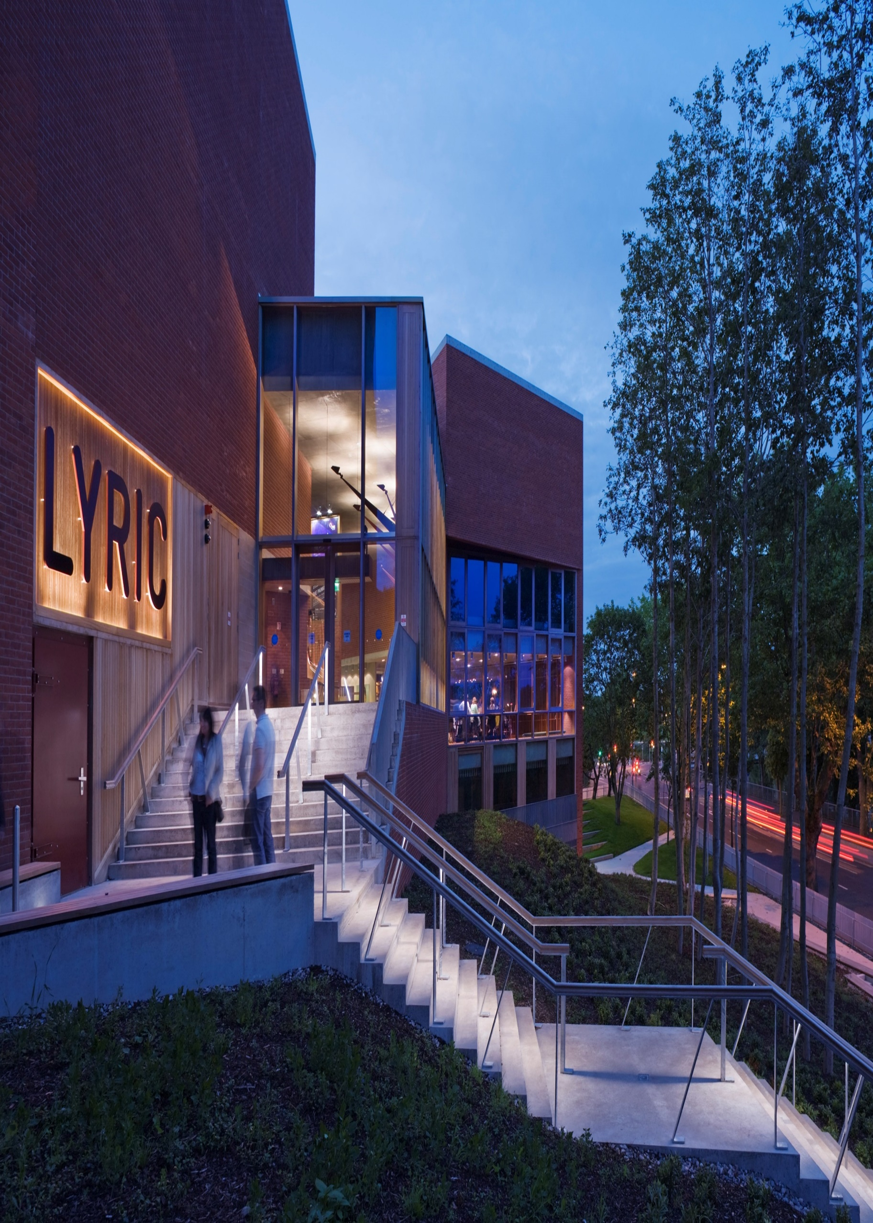

Theatre Technician

Job Description & Application Information

Who We Are
The Lyric Theatre enjoys a special place within Northern Ireland’s artistic landscape. As a prolific production house, the Lyric is the beating cultural heart of Northern Ireland – inspiring and entertaining audiences with both new and established plays and helping to launch the careers of some of our most famous actors, directors, and playwrights. The Lyric is a playhouse for all. We are a shared civic space for artists and audiences alike; a creative hub for theatre-making, nurturing talent and promoting the critical role of the arts in society.
As Northern Ireland’s only full-time producing theatre, each year we produce 9 or 10 full-scale productions, 2 of which run concurrently at Christmas. We also receive visiting work from touring companies. We stage some 400 performances each year and are the largest employer of theatre practitioners in Northern Ireland. Our modern theatre opened in 2011 and consists of the 390-seat main stage and the 124- seat flexible Naughton Studio. In recent years, the theatre has won multiple awards including Stage UK’s Theatre of the Year 2023 and Excellence in Arts Education at the UK Theatre Awards 2022. We have staged co-productions with the Abbey Theatre, Soho Theatre and the Dublin Theatre Festival and toured to New York, London, Glasgow, and Dublin.
There are two group companies. Lyric Theatre NI (The parent company) is a company limited by guarantee and a registered charity and is also the owner and operator of the theatre and the primary recipient of grant funding. Lyric Players Theatre Productions Limited is a wholly owned subsidiary of Lyric Theatre NI and is responsible for producing professional theatre productions and the operation of food and beverage operations within the theatre. The combined turnover of the two companies is in excess of £4.5million and employ more than 100 employees. For more information on the Lyric Theatre, visit www.lyrictheatre.co.uk.

Our Mission
We are a shared civic space for artists, arts workers, and audiences alike; a creative hub for theatre-making, nurturing talent and promoting the role of the arts in society. Our mission is to create, entertain, and inspire.

Our Values
We are welcoming: The Lyric Theatre is an inclusive and accessible space for all: a creative place to play, learn, question, and explore.
We are nurturing: Our goal is to galvanise, and empower all those who work in the arts, whilst nurturing new generations of talent through the Lyric Drama Studio and our Creative Learning and New Writing programmes.
We inspire and entertain: We aim to provide theatre experiences that entertain and inspire; challenging audiences to explore their own and other stories.



Job Description

Job Title
Theatre Technician

Location
Lyric Theatre, Belfast

Salary
£29,000-£31,700

Contract
Full Time Permanent

Annual Leave
24 days discretionary plus bank/public holidays (currently 11 days). There may be occasions when it is required to work on a public or bank holiday for which a day in lieu will be given.

Reporting to
Technical and Facilities Manager

Working Week
The standard working week will be an average of 43 hours (excluding breaks) over 6 days, Monday through Sunday. Due to the nature of this position the weekly hours worked can vary significantly to meet the operational needs of the theatre and so a considerable degree of flexibility will be required.

Purpose of the Post

There is an in-house team of three multi-skilled theatre technicians who cover all aspects of technical theatre production including sound, lighting, video, stagecraft and flying. The Technical Department also includes a Technical Manager and a Deputy technical Manager. The Technical Department are responsible for the onstage delivery of both the Lyric’s in-house programme and the visiting programme in both performance spaces. They work closely with and as part of the Lyric’s in-house production teams and supervise and support visiting companies who present work at the Lyric.

The technicians are key members of the Lyric Theatre’s operational team acting as duty technicians to ensure fire and health and safety compliance during public performances. They ensure that the performance spaces, technical equipment, and backstage areas are well maintained to provide a safe and efficient working environment for all users of the theatre.
KEY RELATIONSHPS
Head of Production; Technical and Facilities Manager, Production Management; Production and Programming Teams; FOH and Customer Services Team; Building and Facilities Team; Visiting Companies; Contractors.

Benefits
Of course, we provide all the standard entitlements like an employer-contributed pension and statutory pay for sickness, maternity, and paternity leave, but we also have some extras:
- Additional paid day off for your birthday
- Access to a free, confidential counselling service through our Employment Assistance Programme.
- Free beverages from our café/bar.
- Discounted food from our café/bar.
- Free tickets for Lyric productions.
- Free period products in all bathrooms.

Working at the Lyric
There are a range of other elements that make the Lyric a unique and enjoyable place to work:

- Beautiful environment: Enjoy breaks on our exclusive River Terrace.
- Prestigious theatre: Work with well-respected and talented theatre professionals in a multi-award-winning theatre known for high-quality productions.
- Commitment to wellbeing: Access to Mental Health First Aid Training and a supportive work environment.
- Inclusive culture: We’ve rolled out initiatives like being breastfeeding-friendly, providing free period products in our bathrooms, participating in Belfast Pride, and providing BSL training.
- Staff involvement: Engage through Staff Council and Suggestion Box.

Main Duties and Responsibilities

Technical Productions
- To ensure that all Lyric Production’s production teams, and all visiting companies production teams feel welcome, engaged, and received the highest level of technical support available;
- To ensure that all productions which take place in either of the Lyric’s performance spaces achieve the highest possible standard within the available resources of the organisation;
- To support rehearsals as required, including room set up, temporary staging, PA and sound playback;
- To deliver on all aspects of technical theatre production including:
  - Rigging and focusing of conventional and intelligent lighting fixtures;
  - Operation and programming of ETC EOS Family lighting consoles;
  - Set up of video and projector systems;
  - Set up of camera and broadcast systems;
  - Set up of PA, mic’s and sound equipment;
  - Operation and programming of Qlab sound and video playback;
  - Safe loading and operation of counterweight flying systems;
  - Set up of staging systems and other stock staging equipment such as masking flats and other soft masking;
Set up for captioned, audio-described, and other accessible performances

Operational and Financial
- To work a variable rostered schedule to meet the operational needs of the theatre;
- To act as Duty Technician and Duty Safety Officer when required to ensure operational health and safety compliance;
- To ensure that all production and technical work taking place is appropriately planned and staffed;
- To work with visiting companies to ensure their technical needs and staffing requirements are met;
- To ensure that all performance spaces, rehearsal spaces, workshops, gantries, and other working spaces are well maintained;
- To work as part of the team to maintain and repair technical equipment;
- To assist in the maintenance of the Lyrics’ infrastructure;
- To maintain a tidy and safe working environment for all users of the theatre;
- To ensure that all production companies, in-house and visiting, are appropriately briefed with respect to health and safety, first-aid, and fire responsibilities.

Health and safety
- To support the Technical Manager to ensure health and safety compliance across the organisation and to champion good health and safety practices;
- To ensure that technical department and technical area risk assessments are carried out and distributed to all production teams and visiting companies where required;
- To undertake assigned training within the organisations Health and Safety training portal;
- To comply with all relevant legislation including the promotion of a health and safety culture within the production team;
- To be active in the continued development and delivery of a safe and healthy workplace including the development of safe and efficient systems of working;
- To keep abreast of current developments in health and safety;
- To remain current with industry best practices.

This list is for guidance only and is not exhaustive. The post holder will also be required to carry out other reasonable duties as required by the line manager

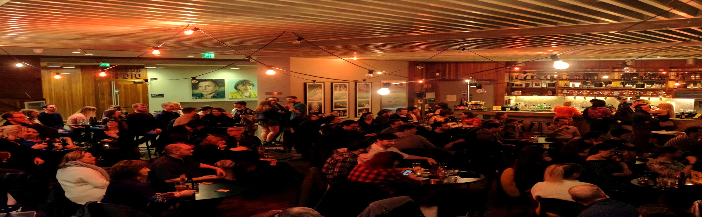
Personnel Specification

Essential Criteria
- A minimum of 2 years’ professional experience or relevant training;
- Knowledge and practical experience of production and technical techniques including set construction, rigging, lighting, sound, and projection;
- Knowledge and experience of lighting and sound setup including ETC EOS family software and QLab;
- Knowledge of Health and Safety legislation and procedures including requirements under LOLER, PUWER, and COSHH;
- Fitness and stamina to fulfil the requirements of the post including the ability to work at height;
- Computer literate, fluent in the use of Excel, Word, PowerPoint, and Outlook applications.

Desirable Criteria
- Knowledge and experience of technical repairs and maintenance;
- First aid or health and safety qualification;
- Knowledge and experience in the use of counterweight flying systems;
- Previous experience of Live Audio Mixing;
- Experience of touring;
- CAD drafting skills (AutoCAD, VectorWorks);
- Knowledge of industry specific codes and standards e.g., ABTT Yellow Book, Theatre Green Book etc;
- Full clean driving licence.

Personal Qualities
- The ability to act on own initiative, dealing proactively with issues that arise;
- The ability to multitask, work calmly under pressure, and meet tight deadlines consistently;
- The ability to prioritise and cope with last minute changes;
- The ability to work well within a diverse range of people at different levels;
- The ability to work with other departments;
- The ability to prioritise and plan their time effectively;
- Strong interpersonal skills. The ability to manage and sustain working relationships with multiple stakeholders;
- An enthusiastic and flexible approach to work;
- An ability to remain, calm, professional and positive when working under pressure;

- The ability to nurture the skills of individuals under their supervision;
- An interest in and enthusiasm for theatre.
How to Apply
Please complete and submit our Application Form, available on our website here, quoting the reference 26LT04 in the subject heading, to recruitment@lyrictheatre.co.uk.
You must also complete our Equal Opportunities Monitoring Form by clicking here - https://forms.office.com/e/nzfVg9wAe5 and entering the same reference 26LT04.
Failure to complete and submit an application form that demonstrates how you meet the criteria will result in your application being disqualified. Canvassing will disqualify.

Closing Date
Midday on 12/05/26. We reserve the right to extend the application deadline, if required, to ensure a comprehensive selection process and attract a strong pool of candidates.

Accessibility
If you require the application in a more accessible format or would like to discuss your application further, please contact recruitment@lyrictheatre.co.uk as soon as possible. We will endeavour to assist with your requests.

Shortlisting
Only those applicants who appear, from the information provided, to be the most suitable in terms of the selection criteria may be called for interview. It is the applicant’s responsibility to demonstrate clearly in their application how they satisfy the published selection criteria. It is essential that applicants provide evidence of how they meet the selection criteria, giving examples and specifying exact dates as appropriate. All applications for employment are considered strictly based on merit.
Guaranteed Interview Scheme
We are committed to fostering an inclusive workplace and actively supporting under-represented groups. If you identify as disabled and meet all essential criteria for this role, you may request to be considered under our Guaranteed Interview Scheme, and we will guarantee you an interview. Please indicate this on your application form.
Please note: this guarantees an interview, not a job offer. All appointments are made on merit.

Interviews
Interviews are planned for week commencing 18/05/2026.

Disclosure
- If you are successful after shortlisting, depending on whether you will be working with children and/or vulnerable adults, you will be required to undergo an ACCESS NI check.
- If you are required to undergo an Access NI check, a copy of their Code of Practice will be made available to you.
- You will also be required to disclose any unspent criminal convictions as defined by The Safeguarding Vulnerable Groups NI Order 2007 & The Rehabilitation of Offenders (NI) Order 1978. The Lyric theatre has a policy on the Recruitment of Ex-Offenders which can also be made available to you.
- Disclosure of a criminal record will not necessarily be a bar to obtaining the position within the Lyric theatre. You will, however, be asked to disclose if there is any reason why you cannot work in regulated activity with children or vulnerable adults.

The Lyric Theatre is an Equal Opportunities Employer.
We particularly welcome applications from People of the Global Majority, disabled and LGBTQIA+ candidates who are under-represented across the sector.
7

